Preliminary Workshop Programme (latest version January 12th 2006)

Date: March 30th – 31st 2006
Hosting Organization: EMPA Swiss Federal Laboratories for Materials Testing and Research
Place: Überlandstraße 129, CH-8600 Dübendorf, SWITZERLAND.

WEDNESDAY 2006-03-29
18:00 – 21:00 | Steering Committee Dinner

THURSDAY 2006-03-30
SAMCO Research Agenda
08:30 – 10:00 | History and Achievements of SAMCO Research Agenda, 7FP | Helmut Wenzel  VCE
10:00 – 10:30 | Coffee Break
SAMCO Achievements
10:30 – 11:00 | SAMCO Guidelines | EMPA / BAM ??
11:00 - 11:30 | WP 4 / Certification | Rainer Flesch  arsenal
11:30 - 12:00 | SAMCO Bridge Management | Livia Pardi  Autorstrade
12:00 – 12:30 | SAMCO Case Studies | Werner Rücker  BAM
12:30 – 13:30 | Lunch
13.30 – 15.00 | Visit of EMPA Laboratories??? | ?
15:00 – 15:30 | Coffee Break
Partner and Member Contributions
15:30 – 16:00 | Hybrid Forced-Natural Excitation System Identification: The Best of Both Worlds? | Guido De Roeck  K.U. Leuven
16:00 – 16.30 | Overview of Fibre Optic Distributed Sensing for Structural and Pipeline Monitoring | Daniele Inaudi" Smartec
16.30 – 17.00 | Discussion | ?
19:00 | SAMCO Dinner at Zeughauskeller / Zurich

FRIDAY 2006-03-31
Partner and Member Contributions
08:30 – 09:00 | Advances in Operational Modal Analysis since the Start of SAMCO | Bart Peeters  LMS International NV
09:00 – 09:30 | Assessment and Control of Vibrations in Lively Footbridges | Álvaro Cunha  University of Porto
09:30 – 10:00 | Assessment of the Earthquake Resistance of Important Existing Buildings - Results from IP LESSLOSS / SP5 | Rainer Flesch  arsenal
10:00 – 10:30 | Coffee Break
Hardware for Monitoring
10:30 – 12:00 |  | ?
12:30 – 13:30 | Lunch
Poster Session for the Access Papers -
Subsequent Discussion
13:30 – 15:00 |  | ?
15:00 – 15:30 | Coffee Break
POST - SAMCO
15:30 – 16:30 | The Future of SAMCO
16:30 – 17:00 | Foundation of the European Association for SAMCO
17:00 | Departure to Airport

Location:

EMPA
Swiss Federal Laboratories for Materials Testing and Research
Überlandstraße 129, CH-8600 Dübendorf, SWITZERLAND

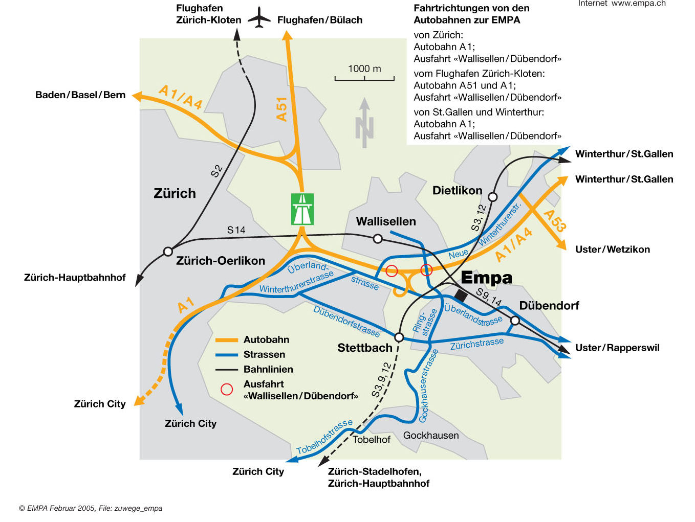

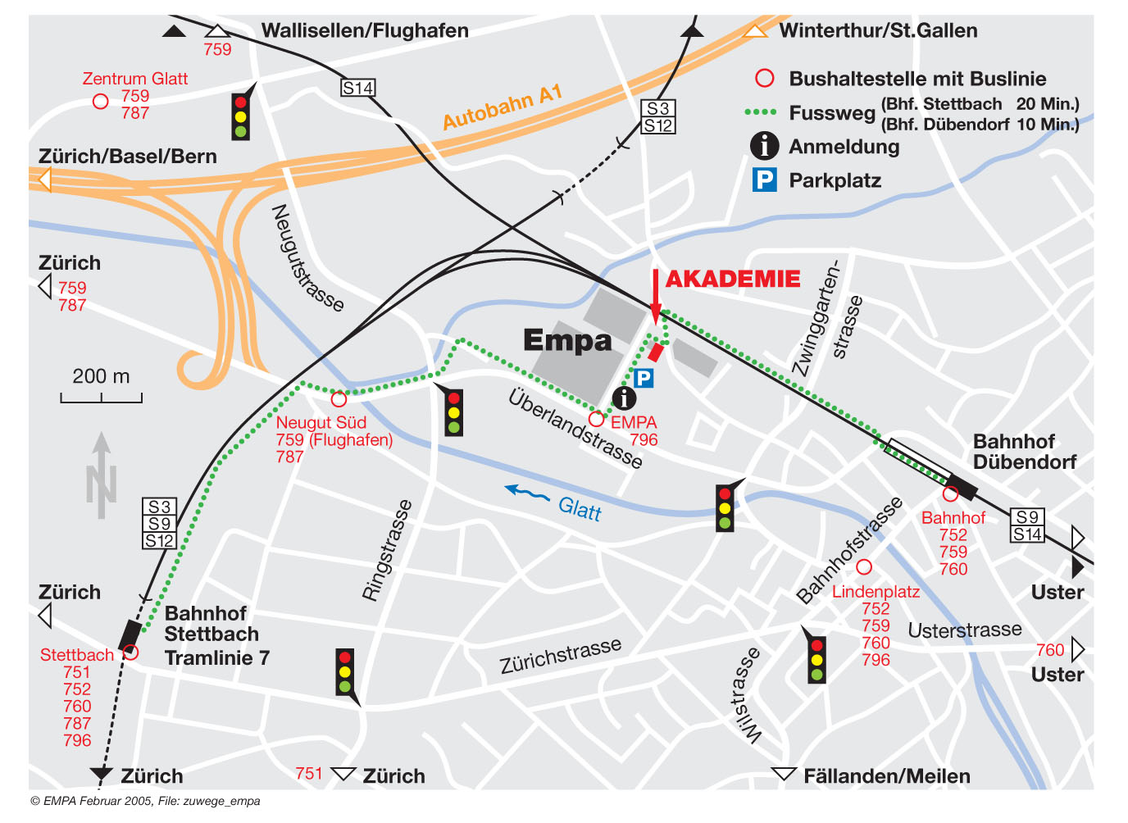

Registration for the Workshop:

Registration is done through VCE Holding GmbH (Coordinator of the SAMCO Network).
Please register by filling in the registration form available on the website:

http://www.samco.org//workshop/download/ws15_reg.doc

- Open the form with the link above
- Fill in the form on your PC
- Print the form
- Send it via Fax to (+43-1) 90 292 2123.

